Processing multiple files

Given the following two data files, you need to process the info based on the selected customer.

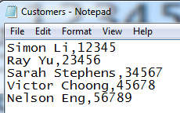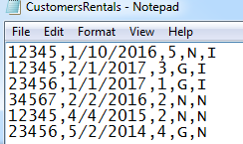

|  |  |
| --- | --- |
| Customers |  |
| Col 1 | Customer name |
| Col 2 | Customer ID |

|  |  |
| --- | --- |
| CustomersRentals |  |
| Col 1 | Customer ID |
| Col 2 | Rental start date |
| Col 3 | Rental duration (days) |
| Col 4 | G: gps required, N: no gps |
| Col 5 | I: insurance required, N: no insurance |

Each column is separated by a comma.

When you form is popping up, the combobox will be loaded with the customer names and IDs

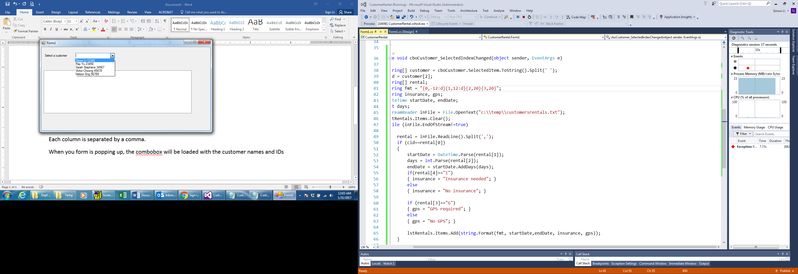

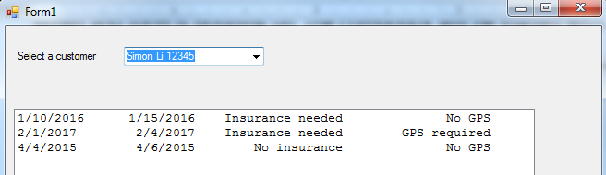

Note: if a customer has no matching rental record, your program will display an appropriate msg in the listbox.

